PROBLEM 3.11

KNOWN: Composite wall of a house with prescribed convection processes at inner and outer surfaces.

FIND: (a) Expression for thermal resistance of house wall, R_{tot}; (b) Total heat loss, q(W); (c) Effect on heat loss due to increase in outside heat transfer convection coefficient, h_{o}; and (d) Controlling resistance for heat loss from house.

SCHEMATIC:
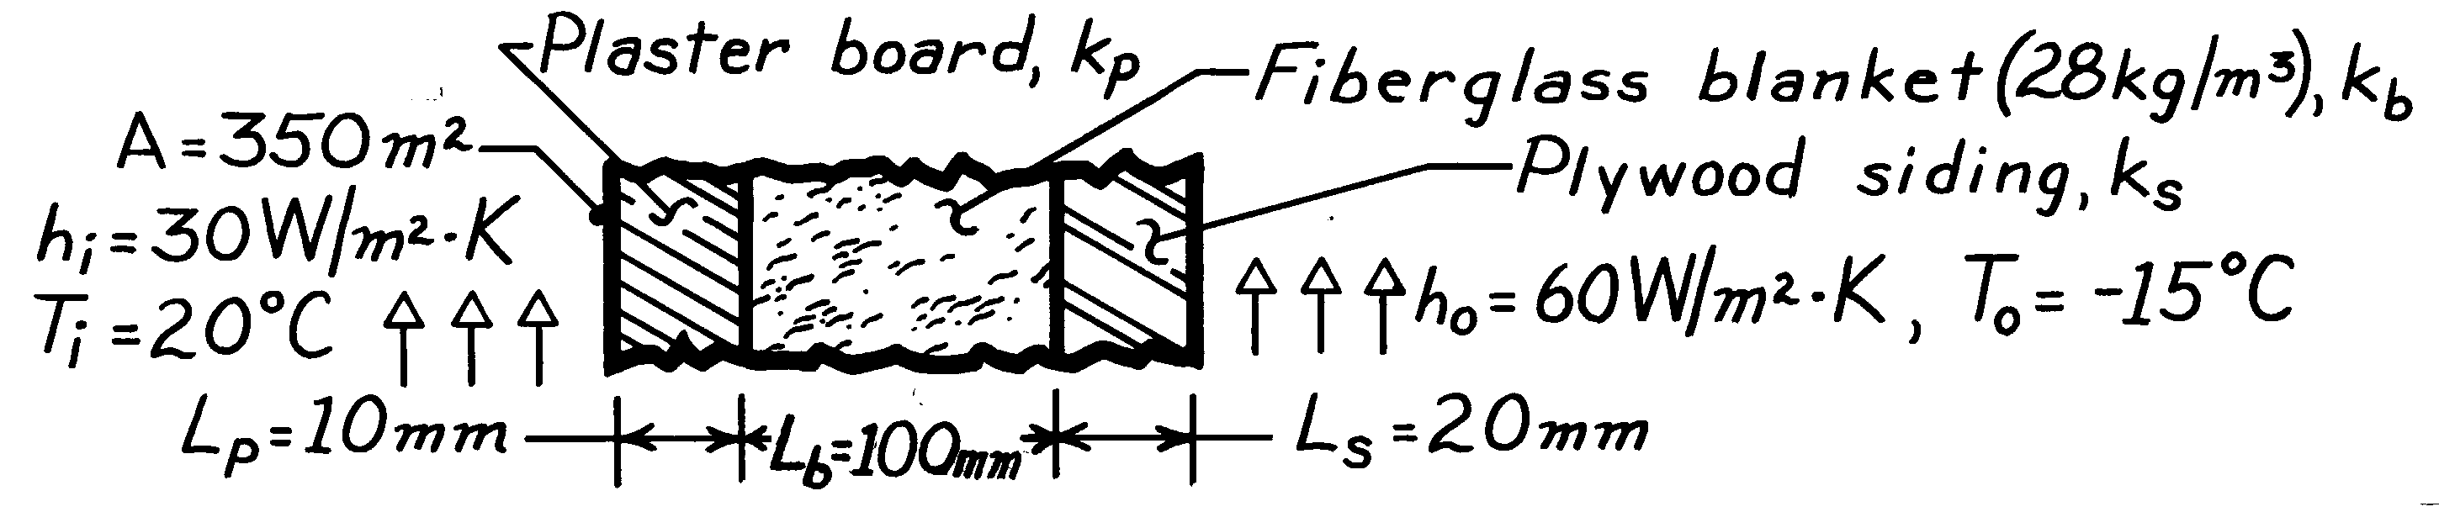

ASSUMPTIONS: (1) One-dimensional conduction, (2) Steady-state conditions, (3) Negligible contact resistance.

PROPERTIES: Table A-3, 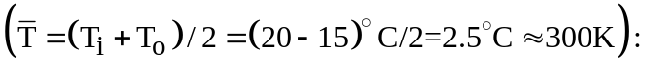 Fiberglass blanket, 28 kg/m³, k_{b} = 0.038 W/m⋅K; Plywood siding, k_{s} = 0.12 W/m⋅K; Plasterboard, k_{p} = 0.17 W/m⋅K.

ANALYSIS: (a) The expression for the total thermal resistance of the house wall follows from Eq. 3.18.
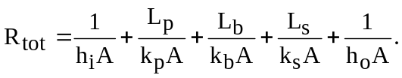 <
- The total heat loss through the house wall is
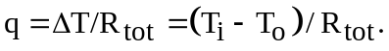

Substituting numerical values, find

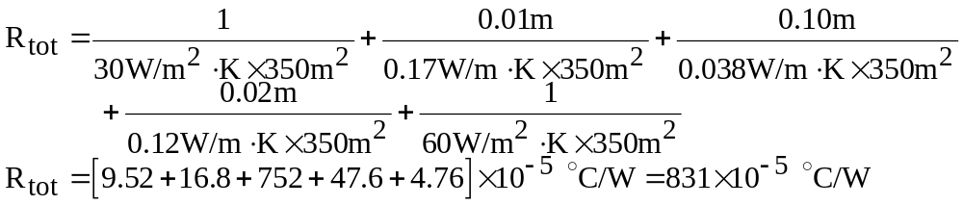

The heat loss is then,
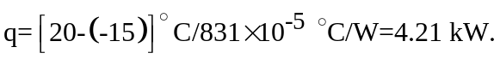 <

(c) If h_{o} changes from 60 to 300 W/m²⋅K, R_{o} = 1/h_{o}A changes from 4.76 × 10⁻⁵ °C/W to 0.95 × 10⁻⁵ °C/W. This reduces R_{tot} to 826 × 10⁻⁵ °C/W, which is a 0.6% decrease and hence a 0.6% increase in q.

(d) From the expression for R_{tot} in part (b), note that the insulation resistance, L_{b}/k_{b}A, is 752/830 ≈ 90% of the total resistance. Hence, this material layer controls the resistance of the wall. From part (c) note that a 5-fold decrease in the outer convection resistance due to an increase in the wind velocity has a negligible effect on the heat loss.

